Streamlining Ticket Assignment for Efficient Support Operations

# Introduction

In large organizations, customer support operations face challenges due to improper or delayed ticket assignments. This often leads to longer resolution times and poor customer experience. By leveraging ServiceNow's capabilities, an automated system can be implemented to assign tickets to the right team or agent based on category, priority, and issue type. This project explores the design, implementation, and evaluation of such a system.

## 1.Create Users:

1. Open service now.
2. Click on All  >> search for users
3. Select Users under system security
4. Click on new
5. Fill the following details to create a new **User**

* User 1(Katherine)
* USER ID: Katherine.Pierce
* First Name: Katherine
* Last Name: Pierce

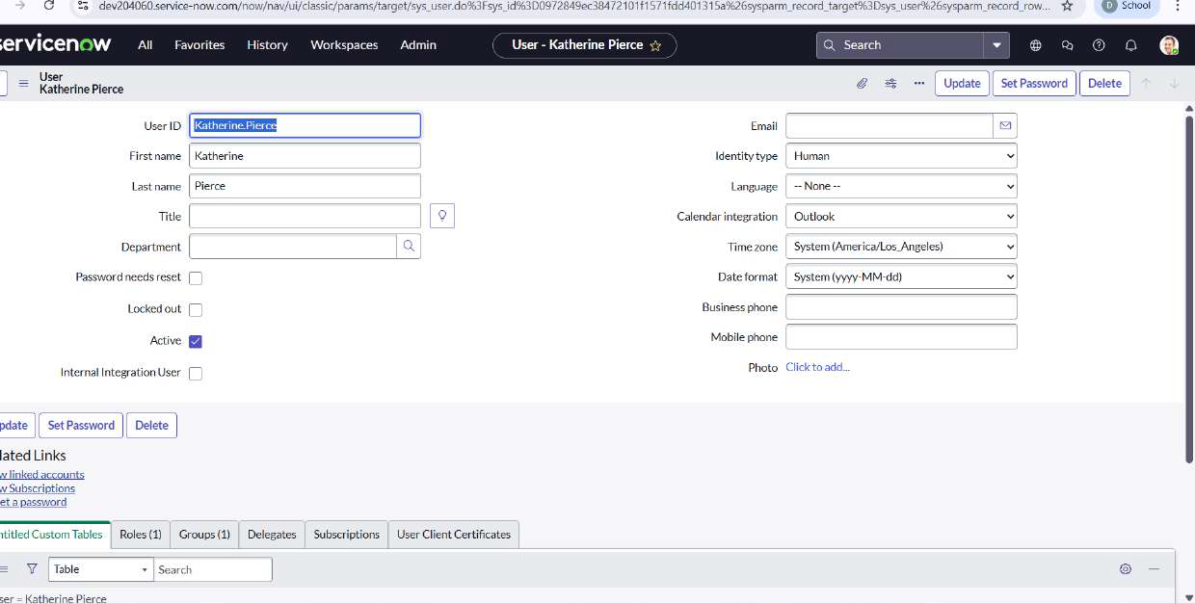

1. Click on **Submit**  
     
   Create one more **User**:
2. Create another **User** with the following details

* User 2(Niranjan)
* USER ID: manne.niranjan
* First Name: Manne
* Last Name: Niranjan



1. Click on **Submit**

2.Create Groups

1. Open service now.
2. Click on All  >> search for groups
3. Select groups under system security
4. Click on new
5. Create a new group named **certificates**   
   
6. Click on **Submit**

Create another group named **platform**:

1. Create another group with the following details  
   
2. Click on **Submit**

3.Create Roles:

1. Open service now.
2. Click on All  >> search for roles
3. Select roles under system security
4. Click on new
5. Create a new role named **Certifications_role:**  
   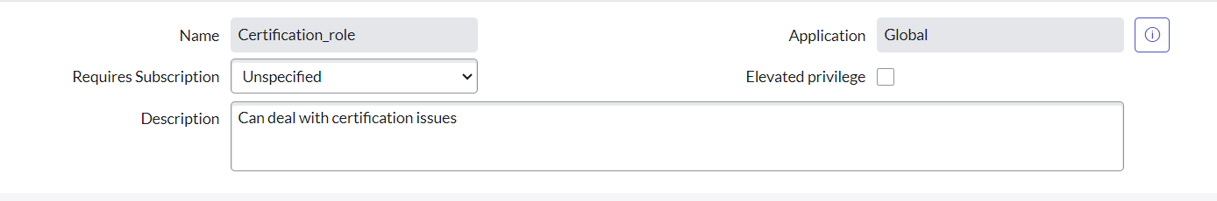
6. Click on **Submit**

Create one more role:

1. Create another role named **Platform_role**:

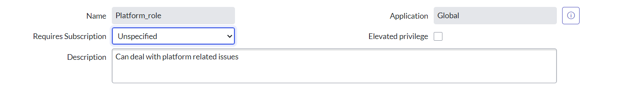

1. Click on **Submit**

3.Create Tables:

1. Open service now.
2. Click on All  >> search for tables
3. Select tables under system definition
4. Click on new
5. Create a new table with Label : **Operations related**
6. Under new menu name : Operations related
7. Under table columns give the columns



1. Click on **Submit**

Create choices for the issue filed by using form design  
Choices are

* unable to login to platform
* 404 error
* regarding certificates
* regarding user expired

**4.Assign roles & users to certificate group**:

1. Open service now.
2. Click on All  >> search for tables
3. Select tables under system definition
4. Select the certificates group
5. Under group members
6. Click on **Edit**
7. Select **Katherine Pierce** and save



1. Click on **Roles**
2. Select **Certification_role** and save



**5.Assign roles & users to platform group**:

1. Open service now.
2. Click on All  >> search for tables
3. Select tables under system definition
4. Select the platform group
5. Under group members
6. Click on **Edit**
7. Select **Manne Niranjan** and save



1. Click on **Roles**
2. Select **Platform_role** and save



**6.Assign role to table**:

1. Open service now.
2. Click on All  >> search for tables
3. Select operations related table
4. Click on the **Application Access**
5. Click on **u_operations_related** read operation
6. Click on the profile on top right side
7. Click on elevate role
8. Click on security admin and click on update
9. Under Requires role
10. Double click on insert a new row
11. Give **Platform role**
12. And add **Certificate role**
13. Click on **update**  
    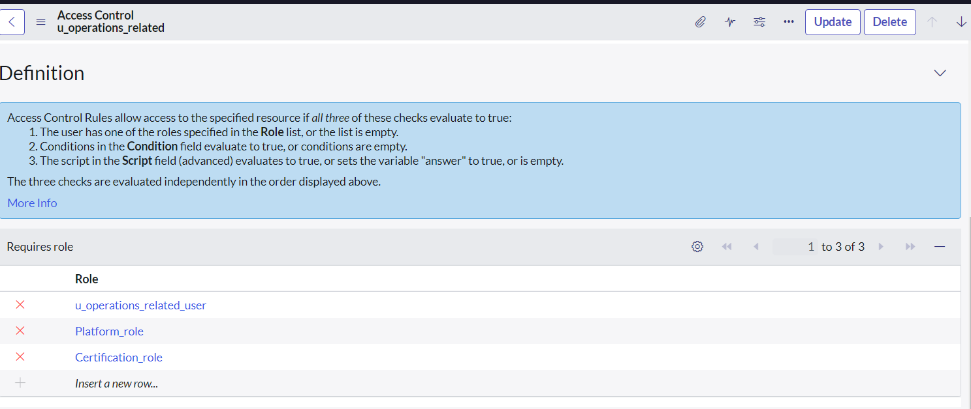
14. Click on **u_operations_related** write operation
15. Under **Requires role**
16. Double click on insert a new row
17. Give **Platform** role
18. And add **Certificate** role

**7.Create ACL**:

1. Open service now.
2. Click on All  >> search for ACL
3. Select **Access Control(ACL)** under system security
4. Click on **new**
5. Fill the following details to create a new ACL  
   
6. Scroll down under **requires role**
7. Double click on **insert a new row**
8. Give **admin** role
9. Click on **Submit**
10. Similarly create 4 **ACL** for the following fields  
    

**8.Flow**:

**REGARDING CERTIFICATE FLOW**

1. Open service now.
2. Click on All  >> search for **Flow Designer**
3. Click on Flow Designer under **Process Automation**.
4. After opening Flow Designer Click on new and select **Flow**.
5. Under Flow properties Give Flow Name as “ **Regarding Certificate**”.
6. Application should be **Global**.
7. Select Run user as **“ System user ”** from that choice.
8. Click on **Submit**.



**TRIGGER:**

1. Click on **Add a trigger**
2. Select the trigger in that Search for **“create or update a record”**  and select that.
3. Give the table name as **“ Operations related ”.**
4. Give the Condition as  
   Field : issue

Operator : is

Value : Regrading Certificates

1. After that click on Done.



**Actions**:

1. Click on **Add an action**.
2. Select action in that search for **“ Update Record ”**.
3. In Record field drag the fields from the data navigation from left side
4. Table will be auto assigned after that
5. Give the field as **“ Assigned to group ”**.
6. Give value as **“ Certificates ”**
7. Click on **Done**.
8. Click on **Save** to save the Flow.
9. Click on **Activate**.



**REGARDING PLATFORM FLOW:**

1. **Open service now.**
2. **Click on All  >> search for Flow Designer**
3. **Click on Flow Designer under Process Automation.**
4. **After opening Flow Designer Click on new and select Flow.**
5. **Under Flow properties Give Flow Name as “ Regarding Platform ”.**
6. **Application should be Global.**
7. **Select Run user as “ System user ” from that choice.**
8. **Click on Submit.**

1. **Click on Add a trigger**
2. **Select the trigger in that Search for “create or update a record”  and select that.**
3. **Give the table name as “ Operations related ”.**
4. **Give the Condition as  
   Field : issue**

**Operator : is**

**Value : Unable to login to platform**

1. **Click on New Criteria**

**Field : issue**

**Operator : is**

**Value : 404 Error**

1. **Click on New Criteria**

**Field : issue**

**Operator : is**

**Value : Regrading User expired**

1. **After that click on Done.** 
2. **Now under Actions.**
3. **Click on Add an action.**
4. **Select action in that search for “ Update Record ”.**
5. **In Record field drag the fields from the data navigation from left side**
6. **Table will be auto assigned after that**
7. **Give the field as “ Assigned to group ”.**
8. **Give value as “ Platform ”.**
9. **Click on Done.**
10. **Click on Save to save the Flow.**
11. **Click on Activate.**



**Conclusion:**

The implementation of the automated ticket routing system at ABC Corporation has been a significant success. By leveraging the capabilities of ServiceNow, we have streamlined the process of assigning support tickets to the appropriate teams, addressing the challenges of manual routing, and ensuring timely resolution of issues.